Day 01 - PostGIS
Dataset: R1-R3-R3_Region_Province_Aquafarm.shp
Preparation: The Docker Compose File
Open your PowerShell in your working directory (where your shapefile is located), create a file named docker-compose.yml, and paste this inside:
version: '3.8'

services:
db:
image: postgis/postgis:15-3.4
environment:
POSTGRES_USER: postgres
POSTGRES_PASSWORD: mysecretpassword
POSTGRES_DB: gisdb
ports:
- "5432:5432"
volumes:
- postgis_data:/var/lib/postgresql/data

pgadmin:
image: dpage/pgadmin4
environment:
PGADMIN_DEFAULT_EMAIL: admin@admin.com
PGADMIN_DEFAULT_PASSWORD: admin
ports:
- "5050:80"
depends_on:
- db

volumes:
postgis_data:

Step 1: Bring PostGIS Online
In your PowerShell window, run this command to download the images and start the containers in the background:
docker compose up -d

Step 2: Connect pgAdmin & Prove PostGIS is Active:
- Open your web browser and go to http://localhost:5050.
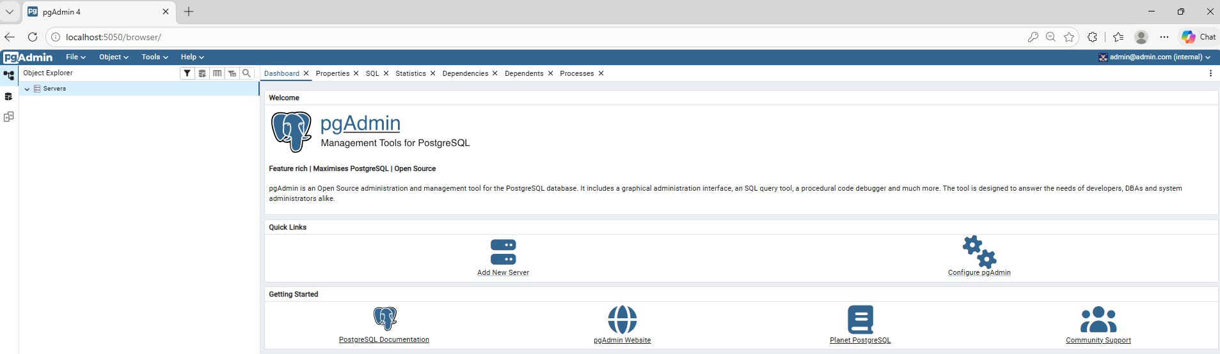
- Log in using the credentials from the compose file:
Email: admin@admin.com
Password: admin

- Right-click Servers > Register > Server...
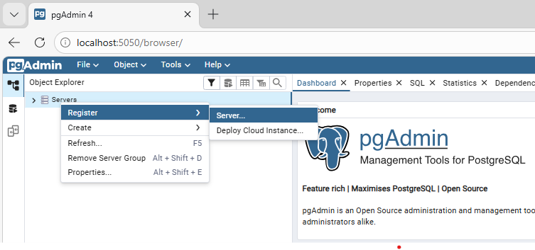
General Tab: Name it something like "Local PostGIS".
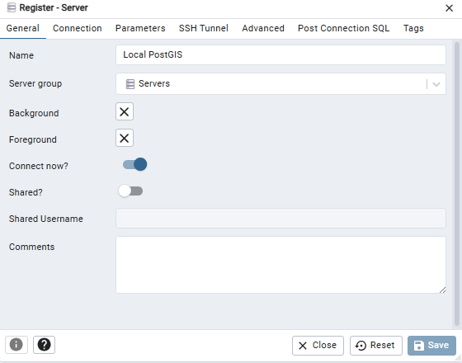
Connection Tab: * Host name/address: db (Crucial: use db, not localhost, because pgAdmin is communicating inside the Docker network).
  - Port: 5432
  - Maintenance database: gisdb
  - Username: postgres
  - Password: mysecretpassword
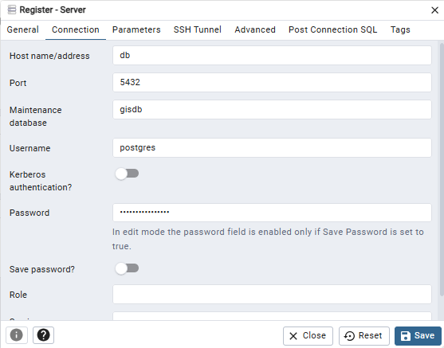
- Save the connection. In the left panel, navigate to Servers > Local PostGIS > Databases > gisdb > Schemas > public > Tables. You will see the spatial_ref_sys table there, proving the PostGIS extension is successfully enabled.
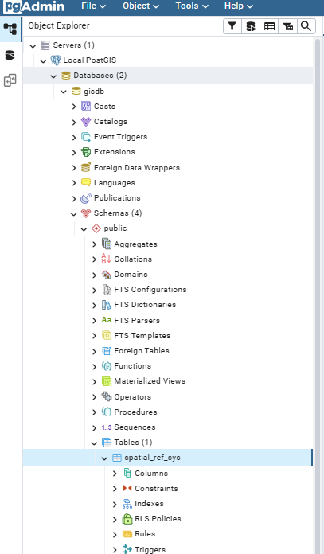

Step 3: Load the Shapefile via ogr2ogr
Since you will be using QGIS, the easiest way to run ogr2ogr is through the OSGeo4W Shell (which installs alongside QGIS).
- Open the OSGeo4W Shell from your Windows Start Menu.
- Use cd to navigate to your working directory.
- Run the following command to push your local shapefile into the Docker database:
ogr2ogr -f "PostgreSQL" PG:"host=localhost port=5432 dbname=gisdb user=postgres password=mysecretpassword" "R1-R3-R3_Region_Province_Aquafarm.shp" -nln aquafarms
(Note: We use localhost here because ogr2ogr is running from your Windows machine, connecting to the exposed Docker port).
- An error may occur stating: Geometry type (MultiPolygon) does not match column type (Polygon). It might have created an empty, broken table in the database. Add an -overwrite flag to wipe the slate clean and start fresh.
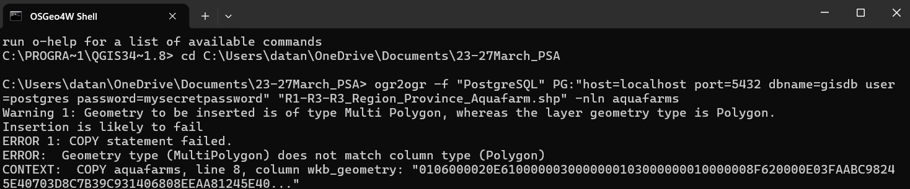
- The Fix: Use PROMOTE_TO_MULTI
ogr2ogr -f "PostgreSQL" PG:"host=localhost port=5432 dbname=gisdb user=postgres password=mysecretpassword" "R1-R3-R3_Region_Province_Aquafarm.shp" -nln aquafarms -nlt PROMOTE_TO_MULTI -overwrite

Step 4: Run a Spatial Query (ST_Intersects)
Head back to your browser with pgAdmin.
- Right-click on your gisdb database and select the Query Tool.
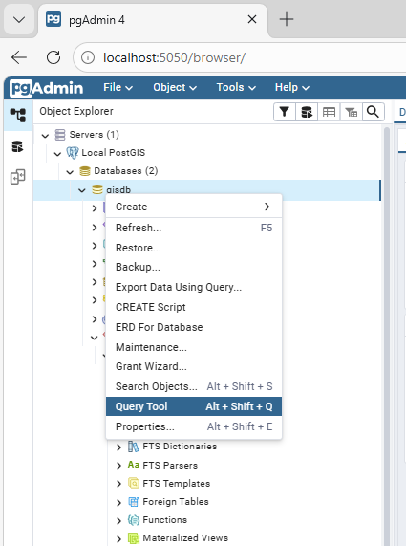
- Run a query using ST_Intersects. Click the Play button (▶️) at the top of the Query Tool (or press F5 on your keyboard).
SELECT * FROM aquafarms
WHERE ST_Intersects(
wkb_geometry,
ST_MakeEnvelope(119.0, 13.0, 122.0, 18.0, 4326)
);

- Look at the Data Output tab at the bottom of the screen. You should see a table of results pop up showing the specific aquafarms that fall inside that area.
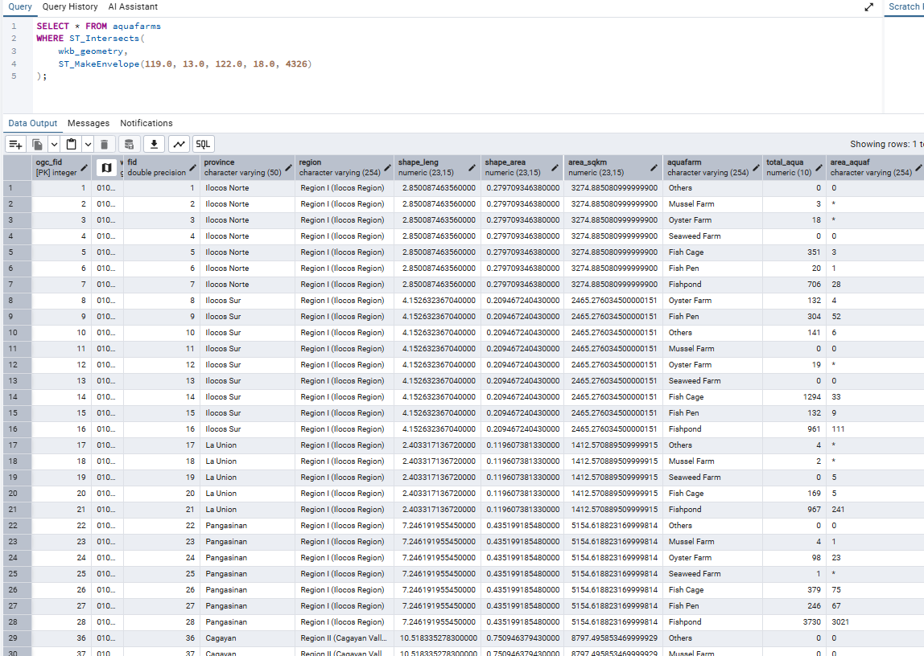

Step 5: Connect QGIS via DB Manager
- Open QGIS.
- In the Browser panel on the left, right-click on PostgreSQL and select New Connection.
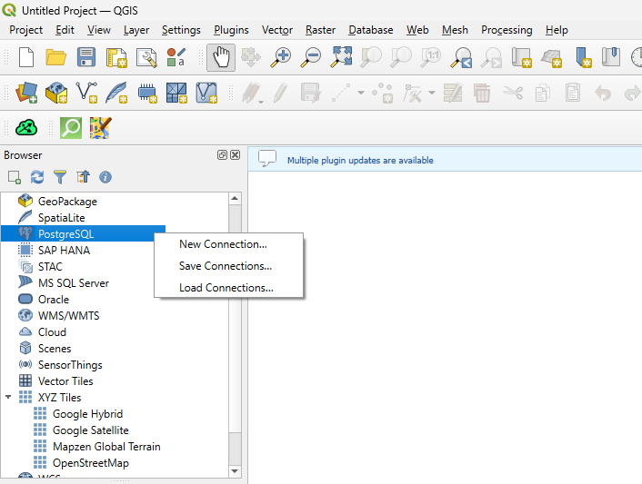
- Fill in the connection details exactly as follows:
  - Name: Local Docker PostGIS (or any name you prefer)
  - Host: localhost
  - Port: 5432
  - Database: gisdb
- Under the Basic Authentication section, enter the database credentials:
  - User name: postgres
  - Password: mysecretpassword
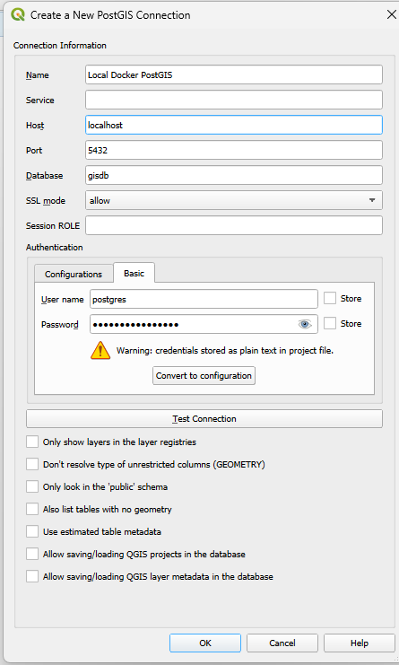
- Click Test Connection at the bottom to ensure QGIS can see the database, then click OK.
- Navigate to the top menu bar and click Database > DB Manager.
- In the DB Manager window, expand the tree on the left: PostGIS > Local Docker PostGIS > public.
- You will see your aquafarms table listed. You can right-click it and select Add to Canvas (or just drag and drop it) to finally visualize your database data on the map!
